1. Important for All Students:
2. You must use Packet Tracer v8.2.0 to complete this lab.
3. Please rename the Packet Tracer file to FirstName_LastName_sNumber_Lab10B.pka

**Student Name** ______________________ **Student ID**

**Instructions**

1. Please type your name and student ID in the spaces above.
2. Please remember to periodically save the Packet Tracer file and this Word document file as you work on the assessment.
3. During the actual Week 12 Network Troubleshooting Assessment, you will have 5 minutes reading time and 90 minutes to solve the network troubleshooting tickets. At the end of the assessment, you will need to submit both the Packet Tracer and Word document files.
4. You can console directly into the devices (ISP, HQ, BRANCH1, BRANCH2, S1, S2, S3, PC1 – PC4).
5. Use **cisco** for all passwords in this assessment, except for the enable secret password, which is **class**.
6. Solve tickets by troubleshooting the network. Each ticket assumes that the previous tickets have been resolved. Therefore, your solutions to later tickets cannot be the same as earlier ones.
7. The table in the last page shows the tickets. List down
   1. the cause of the errors
   2. the commands that you used to troubleshoot the errors
   3. the commands that you used to correct the errors
8. The answer for the command that you used to troubleshoot the errors CANNOT be “show run”. You MUST use other “show” commands to troubleshoot the errors.

Note: To speed up the network convergence process after every attempt to solve the tickets, you can click on the “Fast Forward” button at the bottom left of the workspace.

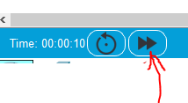

**Network Topology**

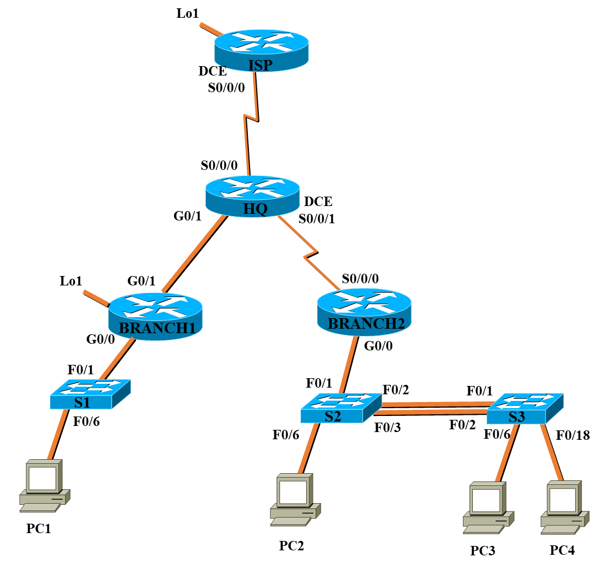

**IPv4 Addressing Table**

|  |  |  |  |
| --- | --- | --- | --- |
| **Device** | **Interface** | **IP Address / Prefix** | **Gateway** |
| **ISP** | S0/0/0 | 200.100.50.1 /30 | N/A |
| Lo1 | 50.50.50.50 /24 | N/A |
| **HQ** | S0/0/0 | 200.100.50.2 /30 | N/A |
| S0/0/1 | 172.16.0.5 /30 | N/A |
| G0/1 | 172.16.0.2 /30 | N/A |
| **BRANCH1** | G0/1 | 172.16.0.1 /30 | N/A |
| G0/0.9 | 192.168.9.1 /25 | N/A |
| G0/0.99 | 192.168.99.1 /29 | N/A |
| G0/0.1000 | N/A | N/A |
| Lo1 | 192.168.13.129 /25 | N/A |
| **BRANCH2** | S0/0/0 | 172.16.0.6 /30 | N/A |
| G0/0.10 | 192.168.10.1 /27 | N/A |
| G0/0.20 | 192.168.20.1 /24 | N/A |
| G0/0.100 | 192.168.100.1 /29 | N/A |
| G0/0.1000 | N/A | N/A |
| **S1** | VLAN 99 | 192.168.99.2 /29 | 192.168.99.1 |
| **S2** | VLAN 100 | 192.168.100.2 /29 | 192.168.100.1 |
| **S3** | VLAN 100 | 192.168.100.3 /29 | 192.168.100.1 |
| **PC1** | NIC | 192.168.9.2 /25 | 192.168.9.1 |
| **PC2** | NIC | 192.168.10.2 /27 | 192.168.10.1 |
| **PC3** | NIC | 192.168.10.3 /27 | 192.168.10.1 |
| **PC4** | NIC | DHCP | DHCP |

**IPv6 Addressing Table**

|  |  |  |  |
| --- | --- | --- | --- |
| **Device** | **Interface** | **IP Address / Prefix** | **Gateway** |
| **ISP** | S0/0/0 | 2001:DB8:ACAE:50::1 /64 | N/A |
| Lo1 | 2001:DB8:ACAD:5::50 /64 | N/A |
| **HQ** | S0/0/0 | 2001:DB8:ACAE:50::2 /64 | N/A |
| S0/0/1 | 2001:DB8:ACAD:1::5 /64 | N/A |
| G0/1 | 2001:DB8:ACAD:2::2 /64 | N/A |
| **BRANCH1** | G0/1 | 2001:DB8:ACAD:2::1 /64 | N/A |
| G0/0.9 | 2001:DB8:ACAD:9::1 /64  FE80::1 link local | N/A |
| G0/0.1000 | N/A |  |
| Lo1 | 2001:DB8:ACAD:13::129 /64 | N/A |
| **BRANCH2** | S0/0/0 | 2001:DB8:ACAD:1::6 /64 | N/A |
| G0/0.10 | 2001:DB8:ACAD:10::1 /64  FE80::1 link local | N/A |
| G0/0.20 | 2001:DB8:ACAD:20::1 /64  FE80::1 link local | N/A |
| G0/0.1000 | N/A |  |
| **PC1** | NIC | 2001:DB8:ACAD:9::2 /64 | FE80::1 |
| **PC2** | NIC | 2001:DB8:ACAD:10::2 /64 | FE80::1 |
| **PC3** | NIC | 2001:DB8:ACAD:10::3 /64 | FE80::1 |
| **PC4** | NIC | SLAAC | SLAAC |

# VLAN Table

|  |  |  |
| --- | --- | --- |
| VLAN | Name | Interface Assigned |
| 9 | Operations | S1: F0/6 |
| 10 | IT | S2: F0/6  S3: F0/6 |
| 20 | Sales | S3: F0/18 |
| 99 | Management_B1 | S1: VLAN 99 |
| 100 | Management_B2 | S2: VLAN 100  S3: VLAN 100 |
| 555 | Parking_Lot | All unused ports in S1  All unused ports in S2  All unused ports in S3 |
| 1000 | Native | N/A |

**Scenario**

In this assessment, the network is already configured. However the configuration contains errors that will prevent end-to-end communication across the network. You will need to troubleshoot the network to determine the cause of the configuration errors, and then use the appropriate commands to correct the configurations.

The network should also have the following requirements met:

* SSH is enabled on all routers and switches (username **admin**, password **cisco**).
* All switches are configured with their relevant VLANs, access ports and trunk ports.
* S2 is the root bridge for VLAN 10 and VLAN 20 on the switched network connected to the BRANCH2 router.
* The links between S2 and S3 form an EtherChannel.
* Inter-VLAN routing (IPv4 and IPv6) is configured on the switch S1 and router BRANCH1, and on the switch S2 and router BRANCH2.
* IPv4 and IPv6 static routing are configured between the routers HQ and BRANCH1, and between the routers HQ and BRANCH2.
* IPv4 and IPv6 static routing are configured between the routers HQ and ISP. The ISP provides Internet connectivity to all the networks behind the HQ router. It has summarized static routes (IPv4 and IPv6) configured to reach all the networks behind the HQ router.
* DHCPv4 is configured on the router HQ to allocate an IPv4 address to PC4. The first 15 usable addresses is excluded from the DHCP pool.
* PC4 is configured to obtain its IPv6 address via SLAAC.

|  |  |  |  |
| --- | --- | --- | --- |
| **Tickets** | **Root cause of error and  on which Device(s)** | **List Command(s) used to Troubleshoot the error and on which Device(s) [An answer of show run will not be accepted]** | **List Command(s) to correct the error and  on which Device(s)** |
| **Ticket 1 [20 marks]** | | | |
| PC2 cannot ping S3 on IPv4. | Ip address of S3’s Vlan 100 is not correct. | Show run | !S3:  Int vlan 100  Ip address 192.168.100.3 255.255.255.248  No shut |
| **Ticket 2 [20 marks]** | | | |
| PC4 cannot ping PC1 on IPv4. | DHCP is incorrect in HQ, PC4 is in 192.168.20.0 network not 192.168.10.0 | Show ip dhcp pool | no ip dhcp pool BRANCH2_LAN20  ip dhcp pool BRANCH2_LAN20  network 192.168.20.0 255.255.255.0  default-router 192.168.20.1  domain-name cisco.com |
| **Ticket 3 [20 marks]** | | | |
| PC1 cannot ping ISP’s Lo1 interface on IPv4. | No summarized static routes on ISP | Show ip route | ip route 192.168.0.0 255.255.128.0 200.100.50.2 |
| **Ticket 4 [20 marks]** | | | |
| PC1 cannot ping PC3 on IPv6. | Vlan 10 not set correctly in S3  No vlan 10 allowed between S2 and S3 | Show vlan br  Show int trunk | !S3:  No vlan 10  Vlan 10  Name IT  Exit  Int f0/6  switchport mode access  switchport access vlan 10  no shut  exit  !S2 and !S3  Int po1  switchport trunk allowed vlan add 10 |
| **Ticket 5 [20 marks]** | | | |
| PC4 cannot ping ISP’s Lo1 interface on IPv6. | Route table of HQ miss PC4 ipv6 network | Ipv6 route | ipv6 route 2001:DB8:ACAD:20::/64 2001:DB8:ACAD:1::6 |